Consentua - A Guide for Admins

Chris Cooper

CTO Consentua

V1

# Document Control

| Version | Publish Date | Author | Changes |
| --- | --- | --- | --- |
| 1.0 | September 2017 | Chris Cooper |  |

# Table of Contents

Document Control 2

Table of Contents 2

Document Purpose 3

Why Consentua 4

What Makes a Successful Project? 5

What is Consentua? 6

Terms & Definitions 7

Setting Up a Consentua Client Service 8

Adding a new client 9

Adding Users 10

Client Consent Service - User Credentials 11

A word about Security 11

Login 12

Admin Tasks 12

Admin Menu 13

Consent Templates 14

Creating Consent Templates 17

Purpose Groups 19

Adding a Purpose 21

Group Consents 23

A Consentua USP - Dynamic changes to consent 24

Consent Queries 25

Support 26

# Document Purpose

The Consentua Guide for Admins is intended to show

* How to set up your Consentua service
* The functions available through the dashboard
* The meaning of terms used
* How to create your own consent templates.

This document is complimentary to the Consentua API Installation Guide (Available via the Consentua Git Repo). The intended audience is IT architects, developers, business analysts, system administrators and user administrators. Additionally, line of business employees such as Heads of department, the CIO, DPO and Lead Counsel will gain insight from reading the document into how to exploit Consentua and ensure it delivers the expected outcomes.

# Why Consentua

Consentua may have been picked for your organisation for a variety of reasons. However, as Consentua does one thing well, (it captures the consent to process personal data from your customers/users), the likelihood is that this first deployment is about personal data. Why? because the General Data Protection Regulation (GDPR) demands organisations take responsibility for the personal data on their systems.

GDPR covers many areas

* the right to be forgotten
* the right to know the data held on you
* the need for both data processors & data controllers to have a record of your consent.

However, when it comes to consent, the rules are now more specific.

There must be a legal basis for the personal data of your users/customers to be processed. There are several legal bases for processing. If you have a legitimate interest in processing an address to enable a mail delivery for example. When the other bases are not applicable, you can seek explicit consent of the user/customer.

In other circumstances such as marketing, the rules are now much tighter. Allied to the need to adhere to a right to be forgotten and a right to know what personal data is held on your systems means that consent is now more complicated.

This is where Consentua helps. Typical high-level scenarios below describe where Consentua would be of assistance.

Consentua was chosen to be used in your organisation because it met one or several of these business requirements.

Your organization…

* 1. …wants a transparent, easy to understand and swift-to-use method of capturing consent.
  2. …wants to share the consent record with other data processors. This could be for service delivery, operational or marketing purposes, all of which require a common consent view. Consentua provides a view for 3rd parties & internal systems.
  3. …wants a global method of consent capture and a local deployment respecting local language and jurisdiction.
  4. …needs a quick, secure yet easy to install solution, with minimal disruption but high impact. That impact is in GDPR compliance and improved customer satisfaction.
  5. …wants a method of capturing consent across multiple systems but wants only one user interaction.
  6. …has a need for GDPR compliance today, but wants to use the opportunity to better know their customers. Building trust in your brand through an evolution in customer service.

# What Makes a Successful Project?

Heads of business, in particular heads of IT, marketing, customer service, legal/compliance and operations are all stakeholders in delivering a successful Consentua deployment. Pre-requisites for a successful Consentua deployment are:

* Team effort - collaboration across lines of business.
* Output from the Privacy Impact Assessment (PIA) is made available, where available, as this is a key input.
* Phased deployment via a test before releasing into production.

From a strategy perspective Consentua is a facilitator of change. Most organisations evolve, rather than have a revolution. This slower pace of change is a result of practical considerations such as having to keep an existing service and customers happy. Funding and resources available to manage the change, create the new procedures and educate the staff, then advertise this to your users. This all takes time.

Therefore, an added benefit of Consentua is its flexibility. So, as new services are added, outsourced, improved or simply changed, the consent required is likely to evolve as well. Consentua can be updated in real-time. The next time the user interacts with Consentua they can see the new consent request.

The service builds out from a scenario, data type, new purposes, new jurisdictions and languages perspective.

# What is Consentua?

Consentua is made up of an API and a widget that gets installed in your mobile app/browser. The widget is available as an SDK for iOS, Android and HTML5.

Consentua is implemented for use by citizens and customers/end users. Consentua is at home being used by a contact centre team member, or a field operative capturing consent verbally then transcribing this into digital record.

From a system perspective, Consentua creates a machine readable Consent Receipt. Consentua treats a system as it would any end user. It still requires an access token and to be granted permission to access that Consent service.

Consentua has at its core the Consent Template where the data type and data purposes are detailed. The Client Consent Service is specific for that Consentua customer. A customer of Consentua can have multiple Client Consent services. This could be from a jurisdiction perspective or a purpose perspective (for example one as an employee and one as an individual).

A Client Consent service can have multiple consent templates. A consent template can have multiple purpose groups, but it must have specific purposes detailed within each purpose group.

# Terms & Definitions

|  |  |
| --- | --- |
| **Term** | **Definition** |
| Consentua | The Consentua Service |
| API | Application Programming Interface |
| REST | Representational state transfer |
| Consent | Permission for something to happen or agreement to do something. |
| Client | The company using the Consentua service |
| Service | The service provided by the client to their users |
| Client User | Users of the Consentua Service registered by a Client |
| Role | Roles within Consentua that allow access to functionality |
| User | A User of the Client’s Service |
| Consent Template | The template of consents that Users interact with |
| Purpose Group | A Group of Purposes |
| Purpose | The Purpose of the consent, what data will be used and what that data will be used for |
| MD5 | A common hashing algorithm |
| Consent Registrar | A trusted third party that provides consent management according to the GDPR regulations. Consentua is an example of a Consent Register. |
| Consent Receipt | A form of exchanging consent records between consent registrars |
|  |  |
|  |  |

# Setting Up a Consentua Client Service

This step can only be undertaken by Consentua System Administrators. The system admin has the following menu via the dashboard - <https://app.consentua.com>



The Consentua system admin will use the **Add Client** function to set up the Client Consent Service. This first act registers the Consentua customer, creates the first Consentua admin and enables the creation of the first set of consent services to be established for this new Consentua customer.

## Adding a new client

The following is a description of the necessary information required when adding a new client. **Note: this is a Consentua System Admin only task.**

**Name:** Is the primary contact or key admins name.

**ClientName:** Is the name we know this client by.

**Data ControllerCompanyName**: Is the legal trading name of the organisation. This may differ from its trading/common name.

**DataControllerAddress**: Is the registered address.

**DataControllerContact**: This could be the DPO, or the primary contact.

**DataControllerPhone**: is their phone number

**DataControllerPrivacyPolicy:** Links to the organisation privacy policy

**StandardTokenExpiry:** Leave as is at 16000 – this is the length of time the token is valid for.

## Adding Users

Once the new Consentua Client Service is set up, two default roles are set up automatically. These are ADMIN and USER roles. The next step for the system admin is to add the first admin user for the new Client Consent Service.



The Consentua system admin will then share with the first admin their new Consentua credentials. This will be the access email, client key and client ID. Without this information the service cannot be used.

The client key information is found via the view ‘See All clients’.

**FirstName -** User first name

**LastName** - User last name

**Email -** email address of user

**UserName** - Friendly user name (use email as default)

**RoleID** - Inherited by a look up on the ‘Client Roles’ View in the System Admin menu (see below). Default roles are ADMIN (restricted to systems, super users) and USERS (generic access).

**Note: Users can only access the service they have set up (linked to their identifier); admins can see all consent activity on that specific client consent service.**

## Client Consent Service - User Credentials

An example below of the information a user requires to login to the dashboard:

Client Key: 5f16c6f2-406c-46de-a2f5-d1230b6cf902

Client ID: 20

Client email: chris@test.com

You Client Consent information will have been sent to you by the Consentua System Admin. This will enable you to now login to your Consentua service. Please do not share this information, as it will mean other systems and services can access your client consent service.

Please feel free to use the test service credentials above. You will be able to access Public Consent Template, Add users, Add Templates, Add Purposes and Add Purpose Groups.

## A word about Security

A security breach is not an issue. The user token can be revoked at any time. The service is encrypted end-to-end; plus, the service does not store any personal data (other than an identifier). Anyone who accessed the system would only see a string of hashed data.

## Login

At login an Admin is presented with the following screen when visiting <https://app.consentua.com>

## Admin Tasks

The admin has some specific tasks once logged into the Consentua dashboard. This is where they will undertake a number of tasks:

1. Create (or re-use) a Consent Template for your client consent service
2. Add additional admins if required
3. Add systems (as a user) to the Consentua Client Service
4. Add users and issue user apps with their token (in the code update that delivers Consentua).
5. Run queries against Consentua to find out who has consented to what, and when.

## Admin Menu



As of September 2017 - missing Consent query view, bulk user upload,

# Consent Templates

The consent template is where the organisation (Consentua customer) specifies the data types, data purposes and the consents required from that organisation’s users/customers.

Consent Templates come in two forms. Binary - yes/no choices presented to end users and Linear, a granular level of choice.

Templates have a data purpose theme and are then split further into different data purposes. These data purposes can be further refined into different purpose groups.

This allows for a range of complex consent requirements to be presented in a clear, transparent 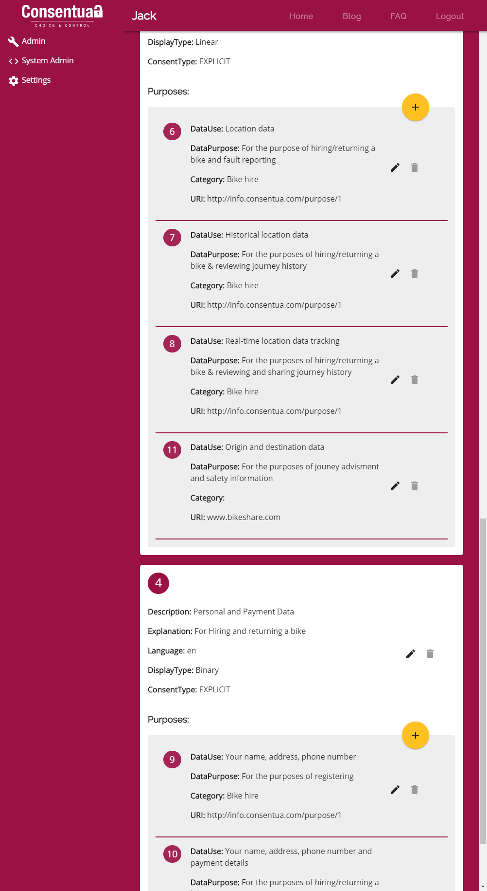and unambiguous format.

The consent template example below is for a bike sharing scheme:

The screenshots below are showing the app view of that same bike share consent template. Notice the different purpose groups. As well as the different types of consent, linear and binary.

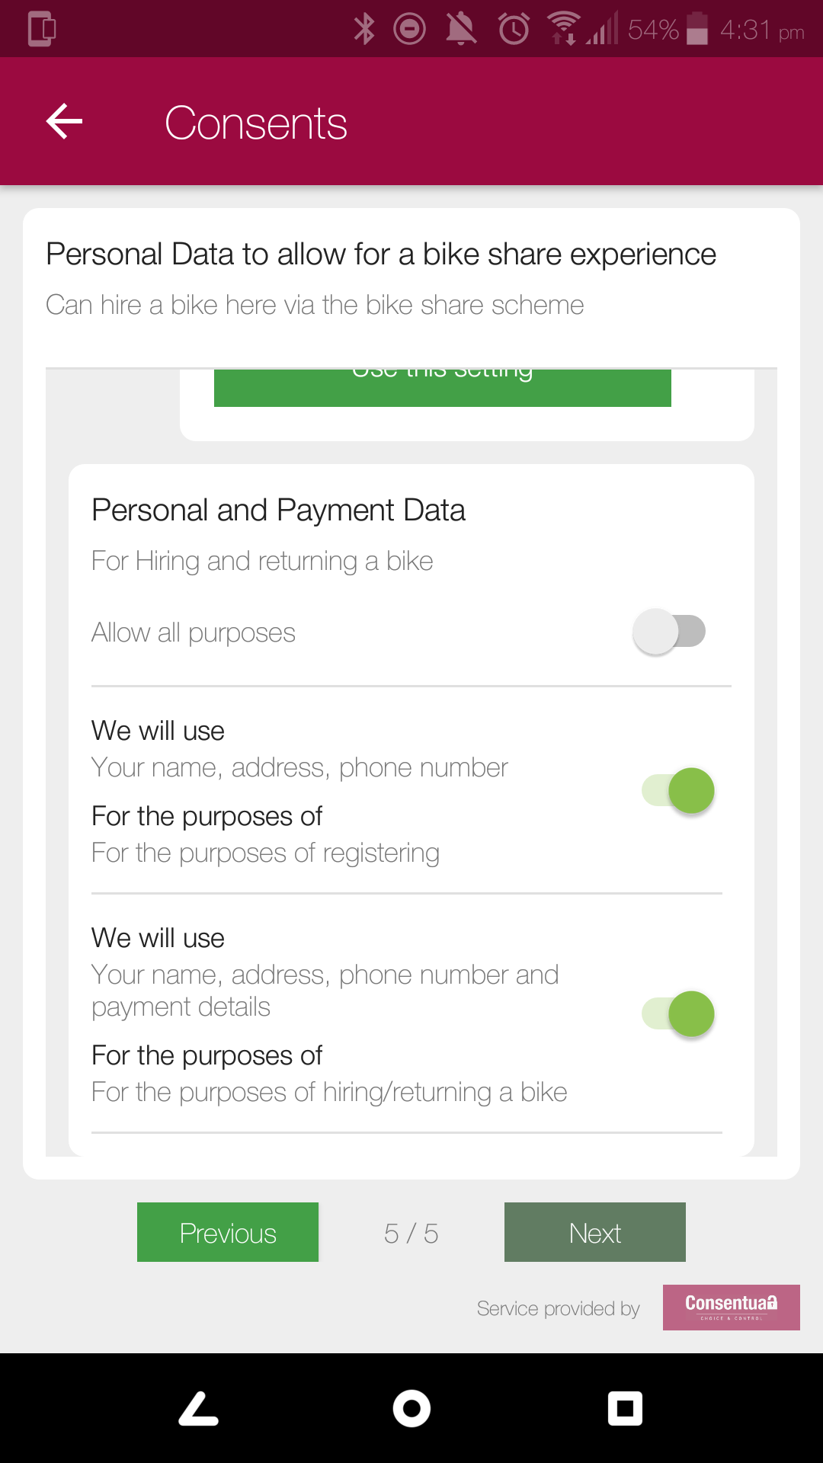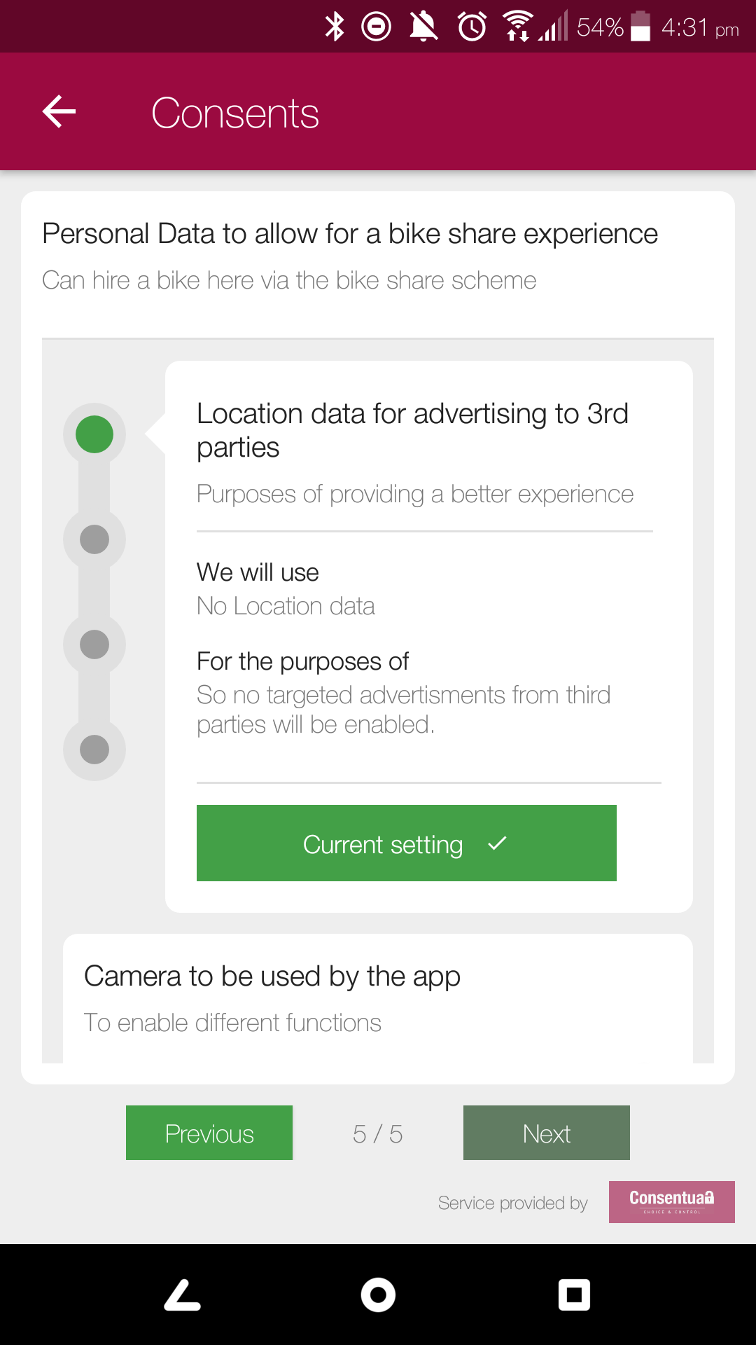

## Creating Consent Templates

For a client consent service to be of use there is a need to create the consent template. Consent templates can be private (exclusive to your client consent service) or public (open to all).

When setting up the template it is important to tie that template to a client consent service. A template can be used by multiple services.

Templates require consideration before being created.

* What the template is to be called?
* What data types and purposes are going to be outlined?
* Is the template going to be binary or linear?

The input for the language of consent being requested needs to come from the business side of the organisation. A mix of marketing, legal, compliance, DPO, Operations, IT and customer service will need to collaborate on the wording of consent. As all these stakeholders have an opinion on the personal data required by the organisation.

This is where the data types (as in what type of personal data is required) and data purposes (how will that requested data be processed and used). It is recommended that templates be created by data purpose. This focuses the use case on how the personal data will be used. Then depending if you are setting up a linear or binary consent interaction, break out how the different data types are then used to fulfil that purpose.

From a linear consent perspective, as the position of the setting increases (0 to 5) then the data types required to fulfil the purpose expand in scope and use.

Consentua aims to simplify the ask to the end user/citizen/customer by linking a data type to a data purpose. This gives the end user/citizen/customer more ‘choice and control’. It also allows the organisation to be more creative, flexible and personal in the service it can provide that end user/citizen/customer.

Each template is given a unique ID. Found in the ‘All Templates’ view. See below

## Purpose Groups

It is possible to have a template with multiple purpose groups. That purpose group will in turn have multiple purposes.

**Note: If a template only has one purpose group, then that group outlines the purposes.**

Most requests are anticipated to require multiple purposes however for a particular data type.

First step is to Add the Purpose Group, then the admin can add the required purposes under this purpose group.

**Note1:** The Purpose Group is best thought of as a scenario/use case. The data types can evolve as the data purposes grow/change.

**Note 2:** A Purpose Group may well be standalone if that group only has one scenario with one data type. It will not require further purposes outlined.

To set this up, go to the Client Consent Services view. Either find an existing template to edit or create a new template. Click on the big yellow + symbol and the following screen pops up.

The Purpose Group ID is allocated automatically by Consentua when the Purpose Group is set up.

**Description: -** Describe the consent that is being requested. Our recommendation is to start with the statement “I consent to….”

**Explanation: -** What will be shared to deliver the service that has been asked for?

**Consent Type:** Either Implicit or Explicit (required for the consent receipt)

**Display Type:** Linear or Binary

**Template ID:**  As purposes need to be signed to a template.

## Adding a Purpose

Once the Purpose Group is established the next step is to add purposes.

Purposes should be focused around the Use Case of the data types to be exploited.

**ID -** Is this ID number of this Purpose Group

**Position** - This is the position of the Purpose in the list.

**Language** - Any language can be used. But a translation table must be available if not English.

**DataUse -** The data type the purpose is focused on.

**DataPurpose -** What will that data be used for?

**URI -** Note the end number is the purpose ID. This is for the Consent Receipt.

[data.consentua.com/purpose/50](http://data.consentua.com/purpose/50)

**Category** - Could be based on department, line of business, functional area, responsible owner.

**Termination URI -** linked to purpose ID. This is for the Consent Receipt.

[data.consentua.com/termination/50](http://data.consentua.com/termination/50)

**PurposeGroupID** - Is the ID of this Purpose Group - Consentua allocates automatically.

**Consent Template ID** - What template is this Purpose Group assigned to.

**DataTypeID -** list of data types - 1 is default. This is for the Consent Receipt.

## Group Consents

Group consents are used in scenarios where the same data type may have multiple purposes dependent on the scenario, location or circumstances. The example below is for a car insurance use case where the brake usage data is used for multiple purposes.

The image below shows a purpose group. The number in the top left corner is the group ID (in this 2). The purposes also have a unique number(PurposeGroupID)

# A Consentua USP - Dynamic changes to consent

Consentua can handle out-of-the-box updates to the consent template that are then realized immediately in the corresponding consent service.

This gives organisations flexibility in how they roll out Consentua across the organisation; or how the organisation interacts with the end user, growing the consent requirements over time as the service develops.

# Consent Queries

To be completed

# Support

For more information please go to [www.consentua.com](http://www.consentua.com). This documentation is updated in the Consentua github repository and there is a link within the docs section of the consentua website.

To enquire about using Consentua services to help you set up please email [contact@consentua.com](mailto:contact@consentua.com)

For enquires about or help with setting up your own client consent service then please email [support@consentua.com](mailto:support@consentua.com)

End Of Document

Consentua from KnowNow Information Ltd

Consentua Trade Mark is owned by KnowNow Information Ltd

KnowNow Information Ltd is registered as a company in England and Wales, number 8781104.

Registered Office: Innovation Space, Halpern House, 1-2 Hampshire Terrace, Portsmouth, PO1 2QF